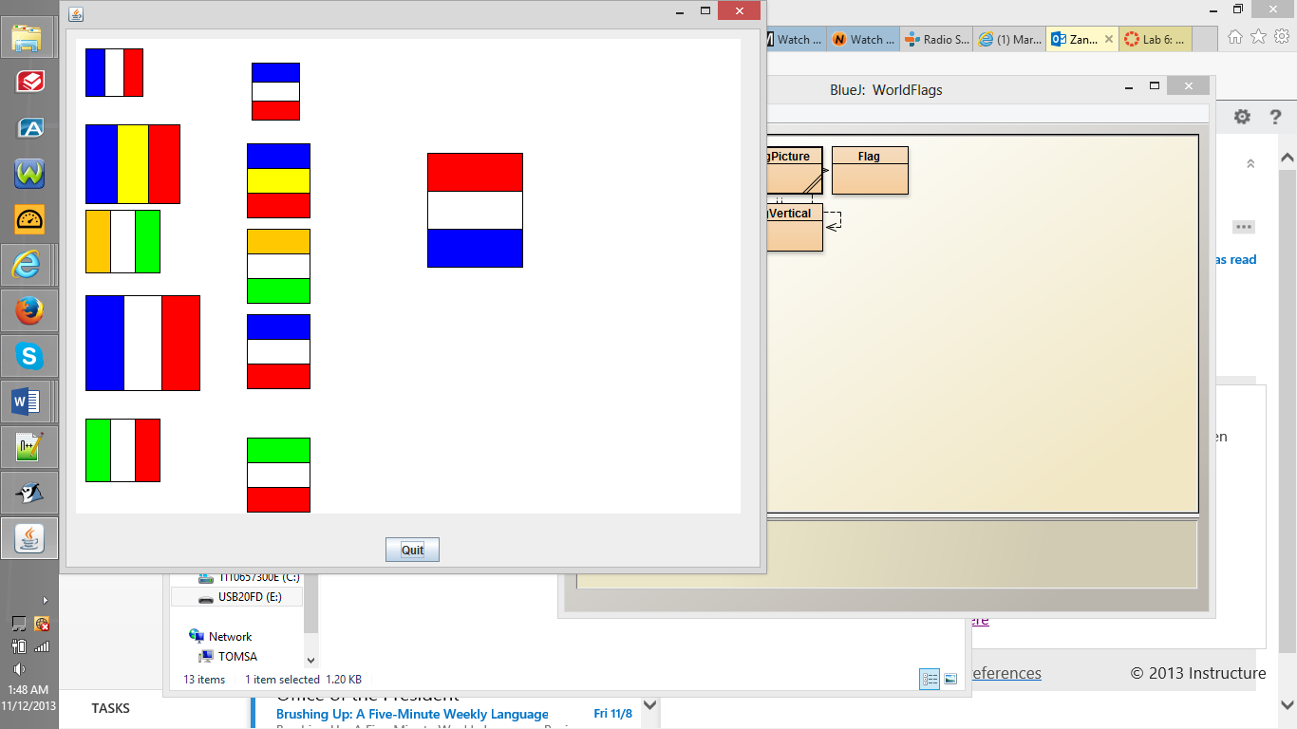

/**

* Write a description of class FlagPicture here.

*

* @author (Thomas Zangari)

* @version (11/6/2013)

*/

import java.awt.Color;

import wheels.users.*;

public class FlagPicture extends Frame{

private Flag _frenchFlag,

_ivoryCoastFlag,

_chadFlag,

_bigFrenchFlag,

_italianFlag;

FlagVertical _frenchFlagVertical,

_ivoryCoastFlagVertical,

_chadFlagVertical,

_bigFrenchFlagVertical,

_italianFlagVertical,

_netherlandsFlag;

public FlagPicture(){

_frenchFlag = new Flag(Color.BLUE, Color.WHITE, Color.RED, 10, 10,60);

_ivoryCoastFlag =

new Flag(new Color(255,200, 0),Color.WHITE, Color.GREEN, 10,180, 80);

_chadFlag = new Flag(Color.BLUE, Color.YELLOW, Color.RED, 10, 90, 100);

_bigFrenchFlag = new Flag (Color.BLUE, Color.WHITE, Color.RED ,10, 270,120);

_italianFlag = new Flag (Color.GREEN,Color.WHITE,Color.RED, 10, 400,80);

_frenchFlagVertical = new FlagVertical(Color.BLUE, Color.WHITE, Color.RED, 200, 10,60);

_ivoryCoastFlagVertical =

new FlagVertical(new Color(255,200, 0),Color.WHITE, Color.GREEN, 200,180, 80);

_chadFlagVertical = new FlagVertical(Color.BLUE, Color.YELLOW, Color.RED, 200, 90, 80);

_bigFrenchFlagVertical = new FlagVertical (Color.BLUE, Color.WHITE, Color.RED ,200, 270,80);

_italianFlagVertical = new FlagVertical (Color.GREEN,Color.WHITE,Color.RED, 200, 400,80);

_netherlandsFlag = new FlagVertical(Color.RED,Color.WHITE,Color.BLUE,400,90,120);

}

public static void main(String[] args) {

FlagPicture picture = new FlagPicture();

}

}

/**

* Write a description of class Flag here.

*

* @author (your name)

* @version (a version number or a date)

*/

import wheels.users.*;

import java.awt.Color;

public class Flag

{

private Rectangle _leftStripe;

private Rectangle _midStripe;

private Rectangle _rightStripe;

public Flag (Color leftColor, Color midColor, Color rightColor, int x, int y, int width){

_leftStripe = new Rectangle();

_midStripe = new Rectangle();

_rightStripe= new Rectangle();

this.setColor(leftColor, midColor, rightColor);

this.setSize(width, (width*5)/6);

this.setOutlineColor(Color.BLACK);

this.setLocation(x,y);

}

public void setColor(Color color1, Color color2, Color color3){

_leftStripe.setColor(color1);

_midStripe.setColor(color2);

_rightStripe.setColor(color3);

}

public void setOutlineColor(Color someColor){

_leftStripe.setFrameColor(someColor);

_midStripe.setFrameColor(someColor);

_rightStripe.setFrameColor(someColor);

}

public void setSize (int width, int height){

_leftStripe.setSize(width/3, height);

_midStripe.setSize(width/3, height);

_rightStripe.setSize(width/3, height);

}

public void setLocation(int x, int y){

_leftStripe.setLocation(x,y);

_midStripe.setLocation(x + _leftStripe.getWidth(), y);

_rightStripe.setLocation(_midStripe.getXLocation() + _midStripe.getWidth(), y);

}

}

/**

* Write a description of class Flag here.

*

* @author (your name)

* @version (a version number or a date)

*/

import wheels.users.*;

import java.awt.Color;

public class FlagVertical

{

private Rectangle _leftStripe;

private Rectangle _midStripe;

private Rectangle _rightStripe;

public FlagVertical (Color leftColor, Color midColor, Color rightColor, int x, int y, int length){

_leftStripe = new Rectangle();

_midStripe = new Rectangle();

_rightStripe= new Rectangle();

this.setColor(leftColor, midColor, rightColor);

this.setSize(length, (length*5)/6);

this.setOutlineColor(Color.BLACK);

this.setRotation();

this.setLocation(x,y);

}

public void setColor(Color color1, Color color2, Color color3){

_leftStripe.setColor(color1);

_midStripe.setColor(color2);

_rightStripe.setColor(color3);

}

public void setOutlineColor(Color someColor){

_leftStripe.setFrameColor(someColor);

_midStripe.setFrameColor(someColor);

_rightStripe.setFrameColor(someColor);

}

public void setSize (int length, int height){

_leftStripe.setSize(length/3, height);

_midStripe.setSize(length/3, height);

_rightStripe.setSize(length/3, height);

}

public void setLocation(int x, int y){

_leftStripe.setLocation(x,y);

_midStripe.setLocation( x , y + _leftStripe.getWidth() );

_rightStripe.setLocation(x, _midStripe.getYLocation()+ _midStripe.getWidth() );

}

public void setRotation(){

_leftStripe.setRotation(90);

_midStripe.setRotation(90);

_rightStripe.setRotation(90);

}

}